Dear Second grade parents,

To help you and your child prepare for and celebrate First Reconciliation and First Communion, we have an exciting retreat scheduled for **Date,** at **Location.** Registration begins at **Time** with the retreat beginning at **Time** and ending at **Time**. *Please arrive no later than***fifteen minutes before the start of the retreat** for registration and photos.

Dragon Slayers Live is a fantastic retreat for PARENTS AND CHILDREN, led by renowned author and speaker John Wood and his wife Kristin. John and Kristin present this powerful and fun retreat all over the country, and we are confident you and your child will love this experience!

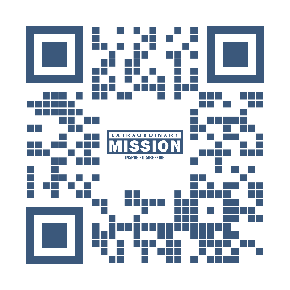In the second hour of the retreat, while the kids are having their own session, John Wood will be offering a **presentation specifically for the parents**. John has spoken at hundreds of parishes and schools across the country, and his book, “Ordinary Lives, Extraordinary Mission,” has sold over a quarter million copies. New York Times Bestselling author Matthew Kelly has said, “I believe John is one of the great emerging Catholic voices of our time. John Wood has a passion that is contagious…read this book and make an effort to hear him speak!” This is NOT an informational meeting, this is an inspiring talk that you DON’T WANT TO MISS! We promise it will be worth your time and help you prepare with your son or daughter for these important sacraments.

While at least one parent is required to attend the retreat with

the child, we recommend that BOTH parents attend. For more

information about the retreat, please use the QR code to watch

the retreat video.

Thank you and we look forward to seeing you on **Date**!

Sincerely,

**-DRE Name**

**-Parish**